1. Which are the top three variables in your model which contribute most towards the probability of a lead getting converted?

Solution:

The following are the top three factors that influence the likelihood of a lead being converted the most, according to the coefficient values from the below screenshot:

* Amount of time spent on the website.
* Have a phone conversation;
* Lead Add Form (from Lead Origin) ( from Last Notable Activity)

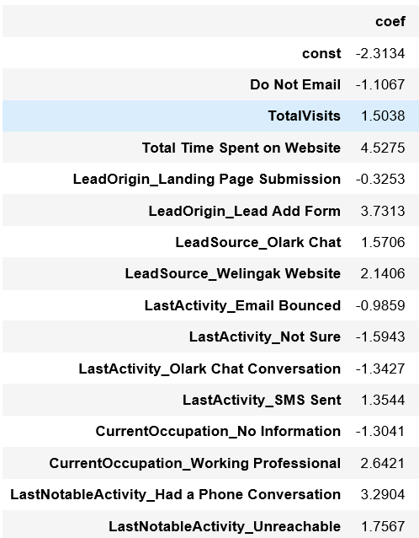

1. What are the top 3 categorical/dummy variables in the model which should be focused the most on in order to increase the probability of lead conversion?

Solution:

Again, based on the coefficient values from the screen shot in the question above, the top three categorical/dummy variables on which the most emphasis should be placed to raise the likelihood of lead conversion are as follows:

* Lead Add Form (from Lead Origin)
* Talked on the phone ( from Last Notable Activity)
* Professionals in the workforce ( from What is your current occupation)

1. X Education has a period of 2 months every year during which they hire some interns. The sales team, in particular, has around 10 interns allotted to them. So during this phase, they wish to make the lead conversion more aggressive. So they want almost all of the potential leads (i.e. the customers who have been predicted as 1 by the model) to be converted and hence, want to make phone calls to as much of such people as possible. Suggest a good strategy they should employ at this stage.

Solution:

The final prediction in the image below was calculated using an ideal cutoff value of 0.37.

The business may contact all leads with a conversion probability (value = 1) under a cut off 0.3 in order to increase sales (column 0.3 highlighted in yellow).

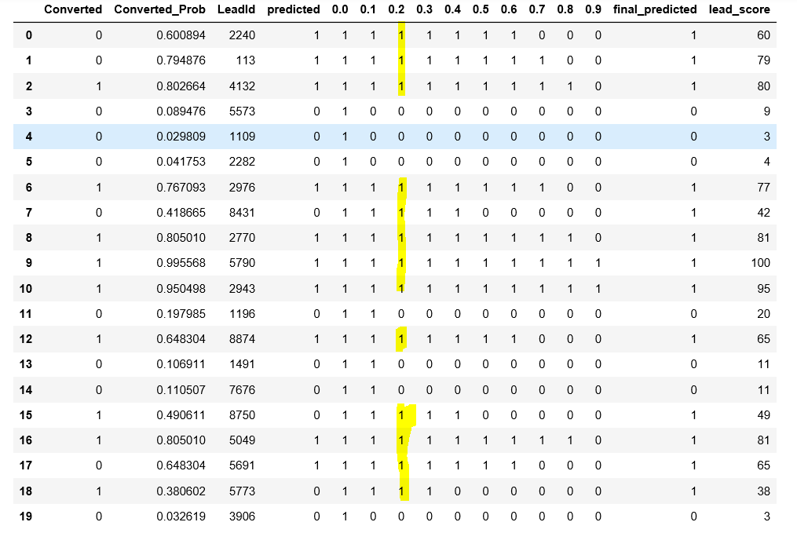

1. Similarly, at times, the company reaches its target for a quarter before the deadline. During this time, the company wants the sales team to focus on some new work as well. So during this time, the company’s aim is to not make phone calls unless it’s extremely necessary, i.e. they want to minimize the rate of useless phone calls. Suggest a strategy they should employ at this stage.

Solution:

The business may call all the leads who have a conversion probability (value = 1 highlighted in yellow) under column 0.7 in order to reduce the number of pointless phone calls. On the other hand, if the model incorrectly projected that a lead would not convert, we can miss out on those that actually do. (Notice red highlights in the image below). Since that the goal has already been reached, there should be little cause for alarm.

